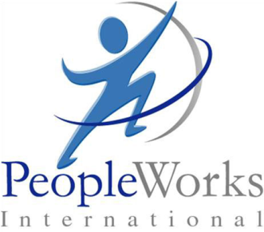
Building Customer Advocacy,
Referrals and Business Performance
By Don Reynolds
Copyright © 2013
Most organizations develop various operating strategies to manage their customers’ expectations. Many set measurable customer relationship and service performance goals. A growing number of organizations broadcast they are in business to exceed all their customers’ expectations.
Unfortunately, however, most organizations are unable to isolate where and how to exceed customer expectations. They are unable to build the kind of desired loyalty, resulting in advocacy and referrals.
Management’s Challenge: How to continuously manage customer expectations that drive customer advocacy and business performance?
- The majority of customer touches requires a management strategy of meeting customer expectations—not exceeding.
- Our client research has shown that less than 15 % of customer interactions create the opportunity to build loyalty leading to advocacy.
- Customer expectations are an ever-increasing moving target. This year’s stellar performance will evolve into next year’s standard.

The Solution: Construct a framework for expectations management. For each customer experience, identify actions designed to meet customer expectations and target approaches that will exceed.
- Identify how customers experience your company and corresponding organization touch points. Define where customers consistently judge the quality of service performance.
- Build a framework that maps the level of customer expectations and desired performance at each touch point. An example of our Customer Performance Expectations Hierarchy is illustrated below.
- Drawing from the framework, prepare a playbook for each customer experience to create a game plan for when and how to exceed customer expectations.

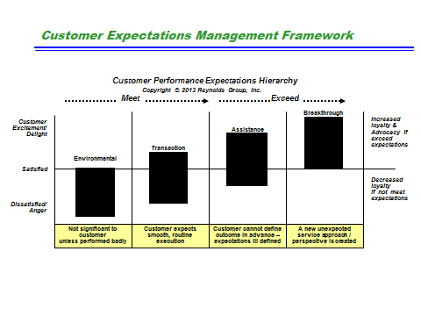

The Challenge Forward —Emerging Customer Empowerment
- Utilizing communications technology and social media applications, the customer will increasingly choose how and when to engage their service provider. These customers will have elevated expectations of speed and information value.
- Employee/customer facing and phone touch points will be selectively displaced by increased use of email, texting and social media technologies. The outcome can be reduced employee/customer engagement, with restricted and fewer assistance opportunities to elevate service levels that can exceed expectations.
- Progressive companies turning to “big data analytics” will condition your customers to expect and seek anticipatory and packaged services as integral to superior relationship management.

The Solution: Reorganize around the customer, and increase employee empowerment
- For transactional customer interactions, re-engineering service design with a continuous improvement process that significantly reduces customer effort.
- Equip employees with communication technology tools and systems that increase competence and responsiveness. Create a service culture that promotes proactive customer service and partnering relationships.
- Where assistance interactions and customer expectations are ill-defined, elevate service levels through employee training and empowerment to deliver the unexpected...the cornerstone of building loyalty and securing advocacy.

About PeopleWorks International

PeopleWorks International is the industry leader in integrating leadership and business strategy with focus areas such as culture change, talent development, and change management in order to accelerate business performance and profitability. We have served multiple fortune 500 companies across the United States and abroad helping them generate results through multiple areas including business strategy, leadership development, mergers and acquisitions integration, turnarounds, and union proofing. Some of our clients include Mitsubishi, EOG Resources, Toyota, Caterpillar, Trinity Industries, JJ Taylor Companies, and Boeing.

For more information please contact us at:
800.505.3978
www.PeopleWorksInternational.com

